Robotics Milestone 4
Team 8

Trajectory Equations:

Joint Circular Trajectory equations:
X(t)= rcos(wt)+c₁
Z(t)= rsin(wt)+c₂
Y(t)= 50*ones(size(t))
Where:
R=100 mm
W=0.2
C1=C2=-100mm
Ones= array of 1s according to t

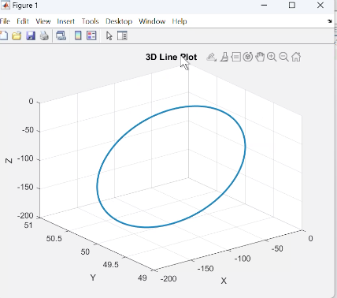

Joint Linear Trajectory Equations:
X(t)= 10t +c
Y(t)= 100*ones(size(t))
Z(t)= 100*ones(size(t))
Where
C=50 mm
Ones= array of 1s according to t

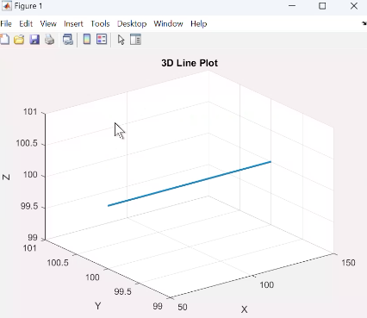

Comments on Simscape:
The matlab code ran smoothly and both circular and linear trajectories shown were as planned and there were no clashes.

Comments on Gazebo:
The code ran smoothly however there were slight differences in the trajectories shown from the obtained Qs.

Comments on the hardware:
The assembly of the robot went as planned however there was a slight issue when working with the servo motors.

